SHIVAJI UNIVERSITY,

KOLHAPUR 416 004

Manual No. 3

[Section 4(1)(b ((iii)]

Right to Information Act 2005

Manual 3
[Section 4(1) (b) (iii)]
The Procedure followed in the Decision - making process,
Channels of Supervision and Accountability
Sr.  No. |  | Section | Details of Activity |  | Days within which Procedure is completed |  | Authority  Responsible for  that activity
1 |  | Establishment  (Administration) | Submission of Monthly  attendance report |  | 10 days before preparation of salary sheet |  | Supdt./.AR/ Dy.R
 |  | Establishment  (Administration) | Sanction of Long leave |  | 3 days before proceeding for leave |  | Supdt./.AR/ Dy.R
 |  | Establishment  (Administration) | Confirmation of staff |  | 15 day after completion of probation period |  | Supdt./.AR/ Dy.R
 |  | Establishment  (Administration) | Issue of various certificates |  | 5 days from demand |  | Supdt./.AR/ Dy.R
 |  | Establishment  (Administration) | Recruitment process Including  Advertisement, Written  Examination, Interview &  appointment |  | Generally within 150 days |  | Supdt./.AR/ Dy.R
 |  | Establishment  (Administration) | Preparation & submission of  pension case |  | 6 months before the date of superannuation of  increment |  | Supdt./.AR/ Dy.R
 |  | Establishment  (Administration) | Placement proposals (CAS) |  | 90 days |  | Supdt./.AR/ Dy.R
 |  | Establishment  (Administration) | Issue of appointment letters |  | 5 days after selection |  | Supdt./.AR/ Dy.R
2 | All Dept. |  | Abstract of inward / outward  register |  |  | 7 days after expiry of the previous month | S.O./ H.O.D.
2 |  |  | Para wise information in court case to be supplied to the law section |  |  | As required by Legal Cell | S.O./ H.O.D.
2 |  |  | Contracts for maintenance of  various Machinery |  |  | 15 days before completion of previous  contract | S.O./ H.O.D.
2 |  |  | Activities which are to be performed annually |  |  | 70 days | Section In  charge
2 |  |  | Preparation of notes |  |  | Generally within 2 days or as per the urgency  of the matter | Assistant
2 |  |  | Correspondence, if required |  |  | Generally within 2 days from the receipt or as  per the urgency of the matter. | Assistant
2 |  |  | Letters to be put up for approval |  |  | Generally within 2 days from the receipt or as  per the urgency of the matter. | Assistant
2 |  |  | Acceptance of forms (any kind) |  |  | Same day as prescribed in the schedule | Concerned Staff
3 | Board of Studies |  | Publication of syllabus |  |  | 15 days before the commencement of the  course | Supdt./.AR/ Dy.R
4 | Affiliation T-1 |  | Sending of selection panel |  |  | 15 days before the date of interview | Supdt./.AR/ Dy.R
4 |  |  | Approval to teachers / Principal | 15 days after necessary compliances |  |  | Supdt./.AR/ Dy.R
5 | Special Cell |  | Verification of roster registers | 7 days from the date of proposal |  |  | A.R/Dy.R
5 |  |  | Scrutiny of Advertisement | 3 days from the date of proposal |  |  | A.R./Dy.R
5 |  |  | Enrolment of names in Reservation Cell | Same day on receipt of the complete proposal |  |  | A.R./Dy.R
5 |  |  | Supply of list of candidates, on  demands | 3 days |  |  | A.R./Dy.R
5 |  |  | Issue of approval of advertisement after following  due process | 1 or 2 days |  |  | AR /Dy.R.
6 | Eligibility |  | Issue of final Eligibility | 15 days after the scrutiny |  |  | S.O. / AR /Dy.R
6 |  |  | Grant of permission for change  in University/faculty, college  subject, readmission | 7 days after prescribed / date of submission is  over |  |  | S.O. / AR /Dy.R
6 |  |  | Eligibility for centralized  admissions | 15 days on receipt of merit list from competent  authority |  |  | S.O. / AR /Dy.R
6 |  |  | Issue of Eligibility certificate | 2 days from receipt of application |  |  | S.O. / AR /Dy.R

Sr.  No. | Section | Details of Activity | Days within which Procedure is completed | Authority  Responsible for  that activity
7 | Examination | Issue of duplicate marks statement,  passing certificates, | 1 day (After 2002-On same day) | Assistant
7 | Examination | Change in Name | 5 days | Assistant
7 | Examination | Issue of Migration/TC certificate on demand | 1 Day | Assistant
7 | Examination | Transcript | Urgent Mode-Within 8 working days  Normal Mode - Within 25 working days | Assistant
7 | Examination | Issue of Hall ticket | 15 days before starting of Examination | Assistant
7 | Examination | Result of Verification | 30 days from the receipt of answer book to the section in normal course | Concerned Staff
7 | Examination | Result of Revaluation | Before commencement of next examination | Assistant
7 | Examination | Conduct of meeting for appointment of examiners for  practical / oral examinations | One month before of the date of practical /  oral examination | Assistant
7 | Examination | Issue of appointment letter to  examiners | 15 days before the date of examination  concern | Assistant
7 | Examination | Preparation and publication of  time table | One month before of the date of examinations | Supdt./.AR/ Dy.R
7 | Examination | Issue of Migration / T C Certificates on demand | 2 days from receipt of application | Supdt./.AR/ Dy.R
8 | Knowledge  Resource Centre | Purchase of books, periodicals  and journals | One month before the start of the academic  year | Concerned Staff
8 | Knowledge  Resource Centre | Classification & accession of  books | 15 days on receipt of books | Concerned Staff
9 | Board of  Sports & Physical Education. | Inter collegiate tournament  activity | August to April every year | Director & President, Secretory of Kolhapur, Sangali, Satara zonal sports council.
9 | Board of  Sports & Physical Education. | Group tournament | August to April every year | Director & President, Secretory of Kolhapur, Sangali, Satara zonal sports council.
9 | Board of  Sports & Physical Education. | Inter University tournament | October to May every year | Director
9 | Board of  Sports & Physical Education. | Coaching camp for inter  University tournament | 10 to 12 days for each event | Director

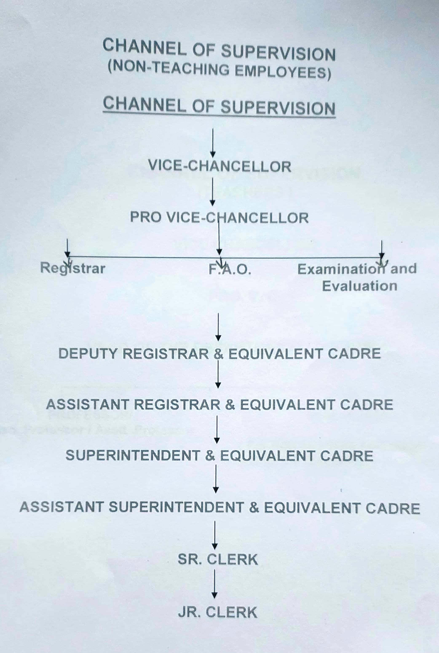

Manual 3

CHANNEL OF SUPERVISION
(TEACHERS )

VICE CHANCELLOR

PRO. V. C.

HEAD OF THE DEPARTMENTS/ DIRECTORS

PROFESSOR/ NON-TEACHING STAFF
Asso. Professor / Asstt .Professor
( For Non-Teaching staff Registrar
will be the Disciplinary Authority )

