EBSCO Discovery Service: 25/10/2018--
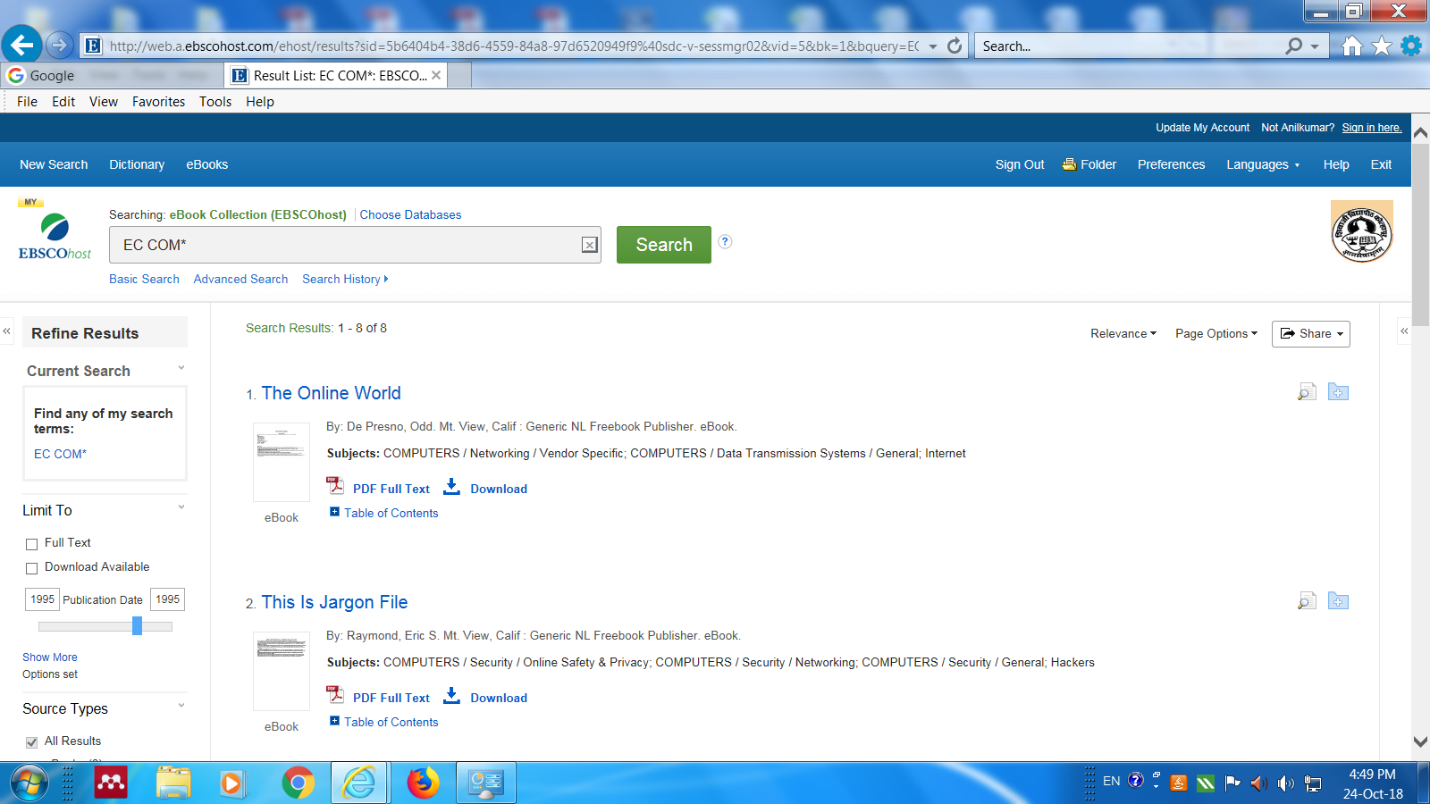

Shivaji University Off-Campus Access from INFLIBNET: INFED: 24/10/2018---
