BIO-DATA 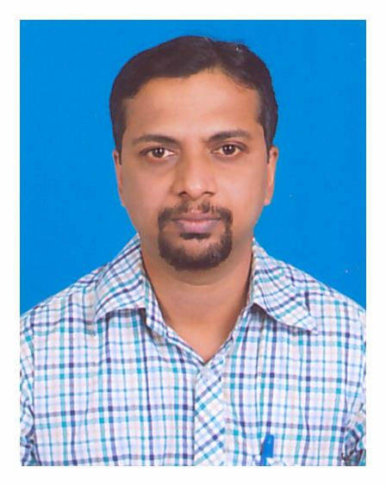

- Name : Dr.Vinod V.Thakurdesai

- Designation : Assistant Professor in Vocal Music
of Music & Dramatics
Department Shivaji University, Kolhapur.

- Address : 503 Vihang Appartment,274/11 Sindhunagari, IT Park
Area, Behind Vishwapandhari,
Near Hockey Stadium,Kolhapur

- Phone :Off.(0231)2609221
Mob.No.+9193256026

- E-Mail ID : vinod_thakurdesai@rediffmail.com
- Educational
Qualifications : 1)M.A(in vocal music)
Shivaji University,Kolhapur,
1st class with distinction,stood first in merit.
75.3%-2002
2)Ph.D in (in Vocal Music)
Shivaji University, Kolhapur.2007
Specialization- Thumari-Ek upshastriya
Geetprakar-Samagra Abhyas

3) B.A. (English_Economics)
University of Mumbai May 1999
(English-Economics)
4) Sangeet Alankar- 1st class(2005)
Akhil Bhartiya Gandharva Mahavidyalaya Mandal,
Mumbai
- Paper published : 04papers published in International
Research Journals
- Teaching experience : Presently working as a fulltime assistant
Professor (Vocal Music) in the Department
of Music and Dramatics,
Shivaji University, Kolhapur from 15 May 2017
till date. Before that I had worked as a
Contributory as well as visiting teacher
From 2005 to March 2017.Teaching
Theory and Practical of vocal music to Diploma
and Master’s degree courses.

- Other Roles and experience
: Apart from teaching I am associated
With D.S.W. Shivaji University,Kolhapur
as a committee member, LIC Committee member.
Also I am worked as a subject expert for Ph.D
Scrutiny committee, thesis evaluation
as well as conducting examinations,
evaluating practical and theory examinations,
paper setting for Diploma, Bridge Course,
M.P.A, Pre Ph.D examinations. Participation
in University cultural activities, lecture
and demonstration, Private concerts etc. are also
the part of my role and experience. Working
as Judge for Youth Festival organized by Shivaji
university, Kolhapur. I have taken workshop on
classical music, organized by KLE University,
Belgaum (2017). I also worked as a judge for various
musical competitions.

- Recognition : All India Radio Graded Artist (B High )

- Name of Gurus in Music : Dr.Sau Bharati Vaishampayan,
Pt.Arun kulkarni,
Pt.Vinod Digrajkar

- Awards& Prizes : 1) Stood First in Merit in M.A. (Music)
2) Research Fellowship was granted by
Shivaji University, Kolhapur for
Ph.D. work for 3 year.
3) Participated in ‘Sangeet Soubhadra’ presented
in 35th Bruhan
Maharashtra Marathi Sangeet Natak
Competition held in New Delhi
Awarded as ‘Best Supporting
Actor and Singer’ - Oct. 2006
4) Adarsha Shikshak Puraskar by Gayan Samaj
Deval Club, Kolhapur in 2006-07
5) Pandit Nana alias Madhukar Sadolikar Prize -
2002
6) Late M. S. Karekar Prize - 2002
7) Late Anand Ramachandra Limaye(Buva)
paritoshik - 2002
8) Stood First in Classical Music
Competitions organized by Shri
Shahu Chhatrapati Sangeet Vidyalaya,
Kolhapur - 2001
9) Stood Third in Late Dr. Vasantrao
Deshpande Smruti Sangeet
(Classical Music) Competition organized
by Abhiruchi, Kolhapur - 2001
10) Stood Second in Wamandji Classical
Singing Competition organized
by Vasantrao Acharekar Sanskrutik
Pratishthan, Kankavali, Sindhudurg– 2001
11) Smt. Sushilabai Ganu Award by Akhil Bhartiya
Gandharva Mandal Mumbai. 2018
- Performance in Musical concerts as well as musical activities :
- I also Presented solo performance of
Classical,Semi Classical and
Light music in various places like
Goa, Ratnagiri,Kolhapur,Pune, Sangli, Belgaum
etc.
- Participated in sangeet natak like
‘Sangeet Samshay Kallol’, ‘Sangeet Shaha Shivaji’,
‘Sangeet Saubhadra’ etc.articipated in various
sangeet natakas like ‘Sangeet Swayamwar’,

